**Industrial Internship Report on**

**”FORMULATE SOCIAL MEDIA MARKETING STRATEGY FOR A NEW PRODUCT LAUNCH”**

**Prepared by**

**[Subiraj Behera]**

| *Executive Summary* |
| --- |
| This report provides details of the Industrial Internship provided by upskill Campus and The IoT Academy in collaboration with Industrial Partner UniConverge Technologies Pvt Ltd (UCT).  This internship was focused on a project: formulating a social media strategy for a new product launch provided by UCT. We had to finish the project including the report in 6 weeks’ time.  My project was ( we need to make a social media strategy to promote a newly launched smart watch of an Electronics company, where we must describe its unique features and identify the social media platforms where we can advertise the product and post about it.)  This internship gave me a very good opportunity to get exposure to Industrial problems and design/implement solutions for that. It was an overall great experience to have this internship. |

## **1** **Preface**

### 1.1 An overview of the entire six-week project:-

In **Week 1**, we learned about the fundamentals of digital marketing, read the ULTIMATE GUIDE TO digital marketing, and chose one of the five projects that were provided.The chosen project is to create a social media plan for the launch of a new product.

SEO (Search Engine Optimisation) was covered in **week 2**. completed the UCT-assigned tasks for competition analysis, market research, the latest digital marketing trends and best practices, and step-by-step project planning.

**Week 3** included lessons on how to use Google Ads and learn how to make money through digital marketing. completed the task assigned by UCT:- Begin implementing my design, strategy, use case, and project.

**Week 4**

Found out what the future of digital marketing entails.

finished the assignment given by UCT:- Continue carrying out my project as planned.

**Week 5**

Got to know about how digital marketing works as a success ladder for businesses.

finished the assignment given by UCT:– assessing quality, performance, and improvement.

**WEEK 6 ( BRIEF OVERVIEW)**

Competitor Analysis:

In this industry smartwatches indicate that many top manufacturers, including Apple, Xiaomi, Fitbit, and others, are active top leaders in this industry. Notifications, alarms, apps, voice reply to messages, media control, fitness tracking, and a very long battery life are just a few of the features which they provide. The market size revenue taken into account in the study is the money generated by smartwatch sales. The study analyses the market in terms of personal support, wellness, healthcare, sports, and other applications.

Market research:

Apple shipped 31 million of its smartwatches in 2019, which is estimated to be 50% more than the whole Swiss watch industry, according to smartwatch market statistics. Since 2018, the number of Apple smartwatches shipped has climbed by 36%. Revenue in the Smartwatches segment is projected to reach US$93.98m in 2023. Revenue is expected to show an annual growth rate (CAGR 2023-2027) of 7.35%, resulting in a projected market volume of US$124.80m by 2027. User penetration will be 0.05% in 2023 and is expected to hit 0.05% by 2027.

The largest smartwatch market in the world is controlled by Apple. The main disadvantages of an apple watch are their skyrocketing price and the fact that they are only compatible with other Apple products. So, if we manage to overcome these crucial issues. We can also develop a sizable market for our watch. The majority of people in India use Android devices. Additionally, there are numerous rivals in the Android smartwatch market. But few are capable of doing the job.

THE FOLLOWING ARE THE STEPS TO BE TAKEN INTO CONSIDERATION FOR FORMATION OF MARKETING STRATEGY:-

* **Premium design**: The watch should have a user-friendly, trend-appropriate design.Given that India has the highest percentage of Android users, premium smartwatches powered by Android will have a larger market share.
* **Reasonable price:** The cost of a smartwatch should be determined based on what an Indian ordinary user will typically pay for one.
* **Excellent features (available exclusively on the Apple Watch) All of these factors**—steps, calories, heart rate, water intake, oxygen metre, and weather app—count. pop-up notifications, an exercise or workout reminder, phone calls, the find my phone app, and the SOS function. Most significantly, functionalities that can aid a typical Indian audience in doing daily tasks must be incorporated.
* **The target market** would include both children and adults who are interested in fitness and health. Given that this smartwatch has fitness and health-related functions. Even children can benefit from features that allow parents to follow their kids' whereabouts and activities on their phone.
* **The theme of the smartwatch and its captions** will be how fitness and health can be affected, as well as how a smartwatch can enhance your life and health and let you enjoy it while maintaining a fit and healthy body. How can making a list of everything your body needs benefit you? How parents may monitor their children's activities, including their location, heart rate, water intake, body temperature, and other important signs that will keep them safe.
* **Advertising and promotion:** We should use all prominent social media sites to continuously increase our reach. However, we should concentrate on advertising via Instagram, Facebook, and YouTube since these are the most widely used social media sites by the general population. As they have a sizable following that follows them, we should interact with fitness and health influencers on social media to market our watch.

The steps taken for implementation and performance assessment are as follows:- Monitoring Social Media Insights and Engagement:-

* **Uphold Continuous Engagement:** Through social media channels like Instagram, Facebook, and YouTube, promote a constant connection between customers and the product brand. Build strong relationships with followers by frequently interacting with them, answering their comments, and starting conversations.
* **Track and analyse insights:** Keep track of engagement metrics, audience demographics, and reach on social media. Utilise this information to learn more about consumer trends, preferences, and behaviour. To achieve the best results, modify your social media strategy accordingly.
* **User-Generated Content (UGC) and a Special Branded Hashtag: -** Develop a Special Branded Hashtag: Develop a Special Branded Hashtag especially for the launch of the smartwatch. Encourage users to use the hashtag when posting their experiences, images, and thoughts. With this tactic, user-generated content is produced, engagement is increased, and a sense of community is fostered.
* **Use Social Media Contests and Giveaways:** Conduct contests and giveaways on social media to pique interest and boost user participation. Encourage users to follow your social media accounts, tag friends, or share how they would use the smartwatch in order to be entered to win pertinent and worthwhile prizes.
* **High-Quality Visuals and Online Advertisements: -** Invest in High-Quality Visuals: Use expert lifestyle photography, product photography, and videos to highlight the smartwatch's appearance, features, and advantages. Potential customers are drawn in and made to feel strongly by compelling visuals.
* **Run Targeted Online Ads:** Use Google AdWords and Facebook as platforms for running optimised online ads. These initiatives raise brand and smartwatch awareness, effectively reaching the target market.
* **Implement SEO strategies**, including performance monitoring and optimisation. Researching keywords will help you improve your website's content and search engine rankings. Utilise both on-page and off-page SEO strategies to increase the smartwatch's online visibility. Keep an eye on the effectiveness of SEO efforts, including image optimisation and keyword rankings. Make data-driven changes to improve the efficiency of SEO.
* **Collaboration and Incorporation of Feedback: -** Incorporate Customer Feedback: Actively gather and take into account public insights and feedback to enhance the marketing strategy. Utilise customer feedback to spot potential weaknesses in the strategy and make the necessary corrections.
* **Form partnerships with well-known brands and industry experts:** Establish partnerships with well-known brands and industry experts in related industries. Partnering with trustworthy organisations can give the product a solid foundation and increase its reach.
* **Create alliances with well-known companies and subject-matter experts:** Form alliances with well-known companies and authorities in related industries. By collaborating with reputable organisations, you can give your product a strong foundation and expand your market.
* **Performance Monitoring with Web Analytics: -** Monitor Digital Marketing Performance: Use various web analytics tools, such as Google Analytics and WebTrends, to continuously monitor the effectiveness of digital marketing initiatives. Analyse data to learn about the success of a campaign and make wise adjustments.
* **Targeting Adult and Youth Markets: -** Concentrate on Adult and Youth Markets: Tailor marketing initiatives to specifically target both adult and youth markets. Create campaigns, messaging, and visuals that speak to the wants, needs, and preferences of each segment.
* **Focus on Fitness and Wellness:** To appeal to the interests and aspirations of the target audience, the smartwatch's theme and captions should be centred on fitness and wellness.
* **Ads should be scrutinised**, so be cautious when promoting products. Pay close attention to the smartwatch's promotion and advertising. Make certain that the messaging and creative communicate the product's features, benefits, and unique selling points in a way that is consistent with the brand image.

### 

### 1.2 Need of relevant Internship in career development

Internships in digital marketing are essential for career development.

Because new platforms are constantly being developed, one of the reasons a career in digital marketing is so exciting is that the industry is constantly changing. A manager of digital marketing constantly monitors trends to determine how they affect discoverability. Getting experience in digital marketing covers pretty much all facets of a brand's online presence. Digital marketing managers monitor search engine updates to see how they affect website rankings. The marketing team as a whole then collaborates to develop a strategy.

### 1.3 Brief about my project/problem statement.

Project: Formulate a social media strategy for a new product launch.

In which we need to make a social media strategy to promote a newly launched smart watch of an Electronics company, where we must describe its unique features and identify the social media platforms where we can advertise the product and post about it.

We must mention the strategy we will be using and use creative themes and captions to promote the smart watch.

I am so grateful to UCT/USC for giving me this opportunity to work with them.

How program was planned:-

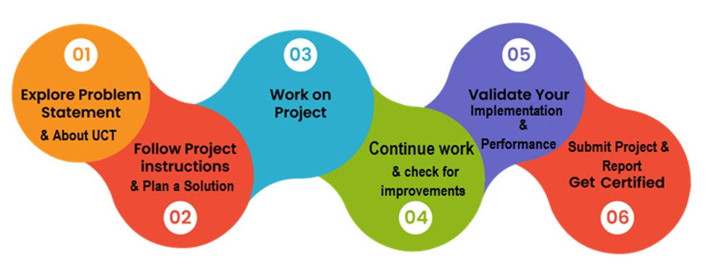

### 

### 1.4 Learnings

Got to learn about so many interesting topics such as:-

* About UCT/USC
* Introduction & Guide to digital marketing
* Introduction to SEO and Google algorithms
* how to earn through digital marketing?
* guide to use Google ads
* What is the future scope of digital marketing?
* How does digital marketing a success ladder to the corporate world?

### 1.5 Experience

A UCT/USC internship was a really wonderful experience. The absence of work pressure was its best feature. They took care to make us feel comfortable while we were at the internship. Everything was handled correctly. Making weekly reports and taking quizzes was a really enjoyable aspect of the internship.

Many thanks to all who helped make my internship a success. Special thanks to the UCT/USC team for always being there to assist us. No matter how busy he was, Apruv Sir was still there to assist and solve the issue.

And to juniors, this is one of the best internships you can get in terms of knowledge and experience. Thanks to a few fellow interns (Brutus, Satya, Rishav, and Shivam) who answered my questions. Continue to assign reports and quizzes.

**2** **Introduction**

## **2.1** **About UniConverge Technologies Pvt Ltd**

A company established in 2013 and working in the Digital Transformation domain and providing Industrial solutions with prime focus on sustainability and RoI.

For developing its products and solutions it is leveraging various **Cutting Edge Technologies e.g. Internet of Things (IoT), Cyber Security, Cloud computing (AWS, Azure), Machine Learning, Communication Technologies (4G/5G/LoRaWAN), Java Full Stack, Python, Front end** etc.



**i.** UCT IoT Platform

**UCT Insight** is an IOT platform designed for quick deployment of IOT applications at the same time providing valuable “insight” for your process/business. It has been built in Java for backend and ReactJS for Front end. It has support for MySQL and various NoSql Databases.

• It enables device connectivity via industry standard IoT protocols - MQTT, CoAP, HTTP, Modbus TCP, OPC UA

• It supports both cloud and on-premises deployments.

It has features to  
 • Build Your own dashboard  
 • Analytics and Reporting  
 • Alert and Notification  
 • Integration with third party application(Power BI, SAP, ERP)  
 • Rule Engine

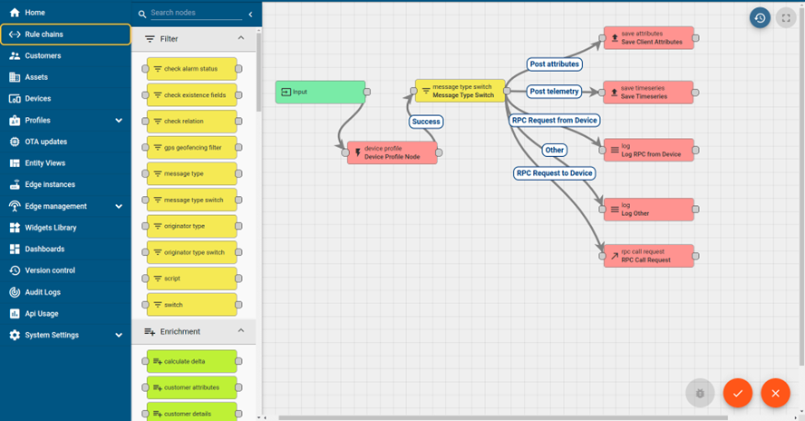

ii. **Smart Factory Platform**

Factory watch is a platform for smart factory needs.

It provides Users/ Factory

• with a scalable solution for their Production and asset monitoring

• OEE and predictive maintenance solution scaling up to digital twin for your assets.

• to unleased the true potential of the data that their machines are generating and helps to identify the KPIs and also improve them.

• A modular architecture that allows users to choose the service that they want to start and then can scale to more complex solutions as per their demands.

Its unique SaaS model helps users to save time, cost and money.

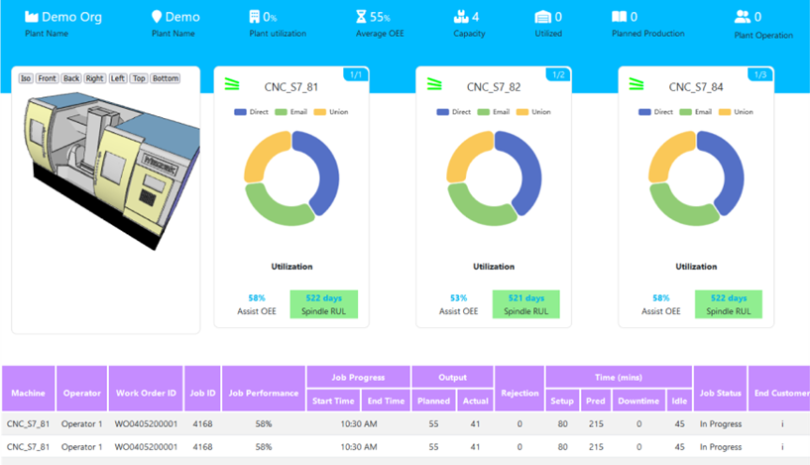

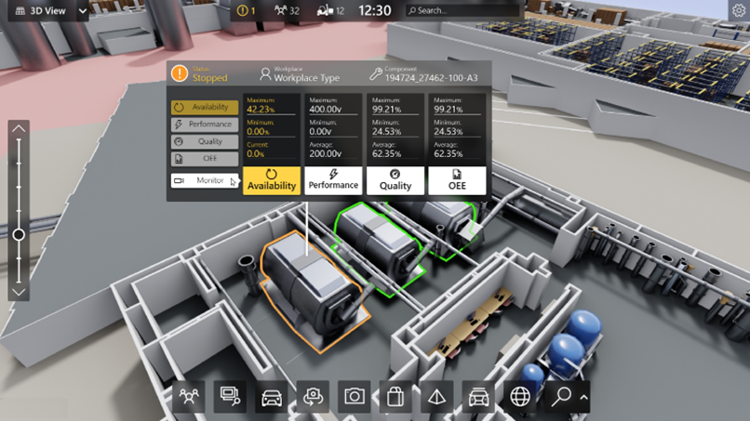

iii.  based Solution

UCT is one of the early adopters of LoRAWAN technology and provides solutions in Agritech, Smart cities, Industrial Monitoring, Smart Street Light, Smart Water/ Gas/ Electricity metering solutions etc.

iv. Predictive Maintenance

UCT is providing Industrial Machine health monitoring and Predictive maintenance solution leveraging Embedded system, Industrial IoT and Machine Learning Technologies by finding Remaining useful life time of various Machines used in production process.

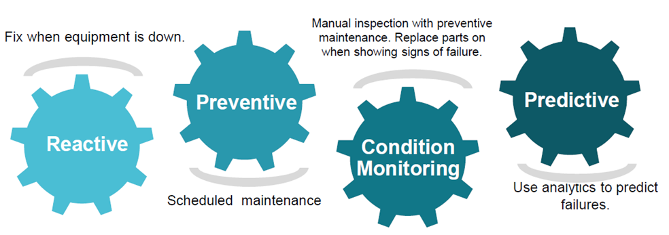

## **2.2** **About upskill Campus (USC)**

upskill Campus along with The IoT Academy and in association with Uniconverge technologies has facilitated the smooth execution of the complete internship process.

USC is a career development platform that delivers **personalised executive coaching** in a more affordable, scalable and measurable way.

| Seeing need of upskilling in self paced manner along-with additional support services e.g. Internship, projects, interaction with Industry experts, Career growth Services |
| --- |

| <https://www.upskillcampus.com/> |
| --- |

| upSkill Campus aiming to upskill 1 million learners in next 5 year |
| --- |

## **2.3** **The IoT Academy**

The IoT academy is the EdTech Division of UCT that is running long executive certification programs in collaboration with EICT Academy, IITK, IITR and IITG in multiple domains.

## **2.4** **Objectives of this Internship program**

The objective for this internship program was to

☛ get practical experience of working in the industry.

☛ to solve real world problems.

☛ to have improved job prospects.

☛ to have Improved understanding of our field and its applications.

☛ to have Personal growth like better communication and problem solving.

## **2.6** **Glossary**

| Terms | Acronym |
| --- | --- |
| SEO | Search Engine Optimization |
| UGC | User-Generated Content |
| RoI | Return on Investment |
| IoT | Internet of Things |
| OEE | Overall Equipment Efficiency |

**3** **Problem Statement**

The following are the problems faced in the assigned project:

* Identifying unique factors among all the competing smartwatches that will aid in the growth of our smartwatch
* Determining the benefits of our smartwatch and the justification for consumers to purchase one.
* identifying the market for which we can most successfully market our product. Choosing the best social media channels to use to promote our product and get the most exposure

# 

# **4** **Existing and Proposed solution**

* Apple smartwatches are renowned for their upscale design and high price tags. Despite being one of the best smartwatches available, they can seriously drain your bank account. The fact that an Apple smartwatch runs iOS and is only compatible with other Apple products is one of its main disadvantages.

And given that India has the largest market for Android users, the solution to this issue is to introduce a smartwatch that runs on Android.

* Samsung products are among the best Android products available, but their smartwatches don't offer much. Because it costs as much as an Apple Watch, you don't get as much premium feel or quality for your money.

Giving the customer the product for what they are paying for it without any terms of cost cutting anywhere is our solution to this problem.

* Regarding the affordable smartwatch segment, there is a sizable market. Despite being more affordable, brands like MI and a few other local brands do not offer the same level of quality or features as their smartwatch competitors. It's their method of reducing the price by reducing the features.

The answer to this issue is to give the customer a positive experience with your product, regardless of how affordable it is. The customer should be happy with the purchase they made.

**4.1** **Report submission (Github link) :**

<https://github.com/subiraj123/social-media-strategy-for-a-new-product-launch..git>

# **5** **Proposed Design/ Model**

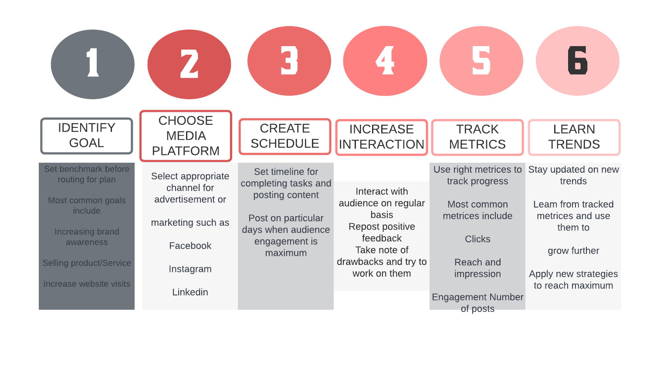

**6** **Performance Test**

* **Time Restrictions:** When launching a product, timing is essential. Before and after the launch, you need to maintain momentum by creating a buzz.

**To deal with time limitations:**

**In advance:** Make sure to include pre-launch, launch day, and post-launch activities in your detailed timeline for your social media strategy.Automate when you can Use social media management tools to automate your content creation process by scheduling posts in advance.

* **Resource Constraints**: The implementation of a social media strategy can be affected by a lack of resources, including money, staff, and technology.

**To get around resource limitations:**

**Prioritise platforms:** Instead of distributing resources too thinly, choose the social media platforms that correspond with your target audience and concentrate your efforts there.

* **Platform Restrictions:** The features, algorithms, and content formats of various social media platforms can be a problem.

**To overcome platform restrictions:**

**Recognise the platform's capabilities:** Learn about the advantages, disadvantages, and user behaviour of each platform. Create content and a strategy that is appropriate.

**Format content as needed:** Make content that can be modified and reused across various platforms while retaining coherence and relevance.

* **Constraints on Audience Engagement:** Engaging and interacting with your target audience can be difficult.

**To overcome obstacles to audience engagement:**

**Make content that is compelling:** Create content that engages your target audience, tells a compelling story, and adds value.

**Encourage involvement:** Engage your audience by incorporating interactive elements like user-generated content campaigns, polls, and contests.

# **7** **My learnings**

I was able to learn a lot and get a better understanding of the field during my internship in digital marketing. Here are some things I discovered during my internship in digital marketing:

* **Digital Marketing Channels:** I gained practical experience with a variety of digital marketing channels, including display advertising, social media marketing, email marketing, search engine marketing, and search engine optimisation (SEO). I gained knowledge about how these channels operate, how to create strategies for each one, and how to assess each channel's efficiency.
* **Analytics and Data Interpretation:** Throughout my internship, I used analytics tools to analyse data, interpret it, monitor key performance indicators (KPIs), and produce reports. This information enabled me to make data-driven recommendations and comprehend the effects of my marketing efforts.
* **Content Creation and Copywriting:** I gained knowledge of copywriting strategies, understood how to create compelling and engaging content for various channels, and learned how to optimise content for search engines. This involved writing content for websites, emails, social media, newsletters, blogs, and more.
* **Industry Knowledge and Trends:** During my internship, I was exposed to the newest market trends, cutting-edge technologies, and industry best practices. Being current with industry knowledge is essential for a successful career in digital marketing, so I made sure to do so.
* **Digital advertising:** I gained knowledge on how to develop successful ad campaigns, target particular audiences, set budgets, improve ad performance, and assess ad effectiveness.

# **8** **Future work scope**

* **User-Generated Content Campaigns:** Encouraging smartwatch buyers to share their stories and demonstrate how they use the product in their everyday lives. Use a branded hashtag to run a user-generated content campaign to gather and share user testimonials, images, and videos. This not only generates social proof for your brand but also real content.
* **Interactive Social Media Contests:** Run contests on social media sites that are interactive to draw in your target audience. For instance, offer users the chance to win a smartwatch by asking them to share their fitness objectives or original watch face designs. Contests can enliven audiences, raise brand recognition, and encourage user participation.
* **Organise live streaming events** to highlight the smartwatch's features, illustrate how it works, and respond to audience questions instantly. On websites like YouTube, Facebook Live, or Instagram Live, live streams can be broadcast. As a result, you can interact with your audience directly and foster a sense of community around the product.